**AP Chemistry Concepts List - KINETICS**

1. Rate definition

2. Rate Law – differential versus integrated

3. Factors affecting rate

a. [C]

b. Δ*T*

c. catalysis

d. surface area

e. nature of reactants – distinguish between homo- and heterogenous

i. solids ii. Liquids iii. gases iv. Ions (solutions)

4. Collision theory – orientation and energy

5. Mechanism – relationship between Δ*T*, Δ*S*, Δ*H* – catalysis

6. Energy of activation (*E*a) – Arrhenius equation – differentiate from Δ*H*



7. Order

a. determined by

i. experimental comparison

ii. graphing

b. zero, first, second – determining % remaining and/or % reacted

ex. Ln (*x*2/*x*1) = *kt*

8. Rate constants with units (units change with reaction order)

a. unsuccessful versus effective collisions

b. orientation and energy

9. Vocabulary

Reactants vs. products vs. catalyst vs. reaction intermediate

10. Mechanisms are consistent if:

- steps add up to balanced equation

- slow step of mechanism will define the mechanistic rate law and rate law expression

- no reaction intermediates in final rate law expression for comparison with the experimental rate law expression

**Free Response Questions**

**1997 #4**

2 A + B → C + D

The following results were obtained when the reaction represented above was studied at 25 °C

|  |  |  |  |
| --- | --- | --- | --- |
| Experiment | Initial [A] | Initial [B] | Initial Rate of Formation of C (mol L-1 min-1) |
| 1 | 0.25 | 0.75 | 4.3 × 10-4 |
| 2 | 0.75 | 0.75 | 1.3 × 10-3 |
| 3 | 1.50 | 1.50 | 5.3 × 10-3 |
| 4 | 1.75 | ?? | 8.0 × 10-3 |

a. Determine the order of the reaction with respect to A and B. Justify your answer.

b. Write the rate law for the reaction. Calculate the value of the rate constant, specifying units.

c. Determine the initial rate of change of [A] in Experiment 3.

d. Determine the initial value of [B] in Experiment 4.

e. Identify which of the reaction mechanisms represented below is consistent with the rate law developed in part (b). Justify your choice.

|  |  |  |
| --- | --- | --- |
| 1 | A + B → C + M | Fast |
|  | M + A → D | Slow |
|  |  |  |
| 2 | B <===> M | Fast equilibrium |
|  | M + A → C + X | Slow |
|  | A + X → D | Fast |
|  |  |  |
| 3 | A + B <===> M | Fast equilibrium |
|  | M + A → C + X | Slow |
|  | X → D | Fast |

*(a) three points*

*1.3* × *10-3 / 4.3* × *10-4 = k (0.75)x (0.75)y / k (0.25)x (0.75)y leads to 3 = (3)x leads to x = 1, first order in A*

*5.3* × *10-3 / 1.3* × *10-4 = k(1.50)(1.50)y/ k(0.75)(0.75)y => 4= 2(2)y => y=1 => First order in B*

*Notes; Verbal descriptions accepted, but no point earned for just "if A doubles, the rate doubles". If A given as second order, 2 points can be earned for showing that B must be zero order.*

*(b) two points*

*rate = k[A][B] (equation must be consistent with part (a))*

*k= 4.3* × *10-4M min-1 / (0.25M) (0.75M) = 2.3* × *10-3 M- 1 min-1*

*Note; Units must be correct to earn second point. If no part (a) shown, 1 point can be earned for a reasonable (first or second order) rate law.*

*(c) one point*

*[A] / t = -2 (5.3* × *10-3 M-1 min-1) = - 1.06* × *10-2 M-1 min-1*

*Note; Units ignored; no penalty for ( ¯ ) sign.*

*(d) one point*

*8.0* × *10 -3 M-1 min-1 = (2.3* × *10-2 M-1 min-1) (1.75 M) [B]*

*[B] = 2.0 M*

*Note; No penalty if answer is consistent with wrong part (b).*

*(e) two points*

*Mechanism 2 is consistent*

*rate proportional to [M][A] and [M] proportional to [B] => rate proportional to [A][B]*

*Notes; Verbal discussion accepted for second point. Mechanism must be consistent with rate law in part (b). Showing that mechanisms 1 and 3 are inconsistent is not required.*

**1999 # 3**

2 NO(g) + Br2(*g*) → 2 NOBr(*g*)

A rate study of the reaction represented above was conducted at 25°C. The data that were obtained are shown in the table below.

|  |  |  |  |
| --- | --- | --- | --- |
| Experiment | Initial [NO] (mol L-1) | Initial [Br2] (mol L-1) | Initial Rate of Appearance of NOBr (mol L-1 s-1) |
| 1 | 0.0160 | 0.0120 | 3.24 × 10-4 |
| 2 | 0.0160 | 0.0240 | 6.38 × 10-4 |
| 3 | 0.0320 | 0.0060 | 6.42 × 10-4 |

a. Calculate the initial rate of disappearance of Br2(*g*) in experiment 1.

b. Determine the order of the reaction with respect to each reactant, Br2(*g*) and NO(*g*). In each case, explain your reasoning.

c. For the reaction,

i. write the rate law that is consistent with the data, and

ii. calculate the value of the specific rate constant, k, and specify units.

d. The following mechanism was proposed for the reaction:

Br2(g) + NO(*g*) → NOBr2(*g*) slow

NOBr2(g) + NO(*g*) → 2 NOBr(*g*) fast

Is this mechanism consistent with the given experimental observations? Justify your answer.

*9 points:*

*(a) Rate of Br2(g) loss occurs at ½ the rate of NOBr(g) formation.*

*Rate of Br2(g) loss = = 1.62 × 10-4 M sec-1 (or mol L-1 sec-1) 1 point*

***Note:*** *No penalty for missing units; ignore + or − signs*

*(b) Comparing experiments 1 and 2, [NO] remains constant, [Br2] doubles, and rate doubles;**therefore, rate α [Br2]1 → reaction is first-order with respect to [Br2]. 1 point*



*x = 2 → reaction is second-order with respect to [NO] 2 points*

***Note:*** *One point earned for a proper set-up, comparing experiments 2 and 3 (as is shown here) or experiments 1 and 3. Second point earned for solving the ratios correctly and determining that the exponent = 2. Also, credit can be earned for a non-mathematical approach (e.g., one point for describing the change in [Br2] and subsequent effect on rate, another point ford escribing the change in [NO] and subsequent effect on rate).*

*(c) (i) Rate = k[NO]2[Br2] 1 point*

***Note:*** *Point earned for an expression that is consistent with answer in part (b)*

*(ii) k = = 105 M -2 sec-1 (or 105 L2 mol-2 sec-1) 2 points*

*(Using rate of Br2(g) loss = 1.62 × 10-4 M sec-1 → k = 52.7 M-2 sec-1 is correct.)*

***Note:*** *One point for solving for the value of the rate constant consistent with the*

*rate-law expression found in (b) or stated in part (c); one point for the correct units consistent with the rate-law expression found in part (b) or stated in (c).*

*(d) No, it is not consistent with the given experimental observations. 1 point*

*This mechanism gives a reaction that is first-order in [NO], and first-order in [Br2], as those are the two reactants in the rate-determining step. Kinetic data show the reaction is second-order in [NO] (and first-order in [Br2]), so this cannot be the mechanism. 1 point*

***Note:*** *One point earned for “No” [or for “Yes” if rate = k[NO][Br2] in part (b)].*

*One point earned for justifying why this mechanism is inconsistent with the observed rate-law [or consistent with rate law stated earlier in response].*

*One point deduction for mathematical error (maximum once per question)*

*One point deduction for error in significant figures* (maximum once per question)*

*\*number of significant figures must be correct within +/− one digit*

**1996 # 8**

The reaction between NO and H2 is believed to occur in the following three-step process.

NO + NO <===> N2O2 (fast)  
N2O2 + H2 → N2O + H2O (slow)  
N2O + H2 → N2 + H2O (fast)

a. Write a balanced equation for the overall reaction.

b. Identify the intermediates in the reaction. Explain your reasoning.

c. From the mechanism represented above, a student correctly deduces that the rate law for the reaction is rate = *k*[NO]2[H2]. The student then concludes that (1) the reaction is third-order and (2) the mechanism involves the simultaneous collision of two NO molecules and an H2 molecule. Are conclusions (1) and (2) correct? Explain.

d. Explain why an increase in temperature increases the rate constant, *k*, given the rate law in part c.

*(a) one point*

*2 NO + 2 H2 🡪 N2 + 2 H2O*

*(b) two points*

*N2O2 and N2O are intermediates*

*because they appear in the mechanism but not in the overall products (or reactants)*

*(c) three points; one for each half of conclusion (1) answer, third for conclusion (2) answer*

*Student indicates conclusion (1) is correct,  
because the sum of the exponents in rate law is 2 + 1 = 3*

*Student indicates conclusion (2) is incorrect,  
because no step involves two NO molecules and a H2 molecule*

*(d) two points; T goes up therefore k goes up:*

*because increasing number of collisions between reactants  
are occuring with sufficient energy to form an activated complex*

*OR*

*T goes up therefore rate goes up  
because no change in concentration of reactants, therefore k must increase*

*OR*

*from Arrhenius equation (not required in AP Chemistry curriculum, but noted in some student responses):*

*as T goes up, k goes up*

**1998 #6**

Answer the following questions regarding the kinetics of chemical reactions.

a. The diagram below at right shows the energy pathway for the reaction O3 + NO → NO2 + O2.

Clearly label the following directly on the diagram.

i. The activation energy (*E*a) for the forward reaction  
ii. The enthalpy change (Δ*H*) for the reaction

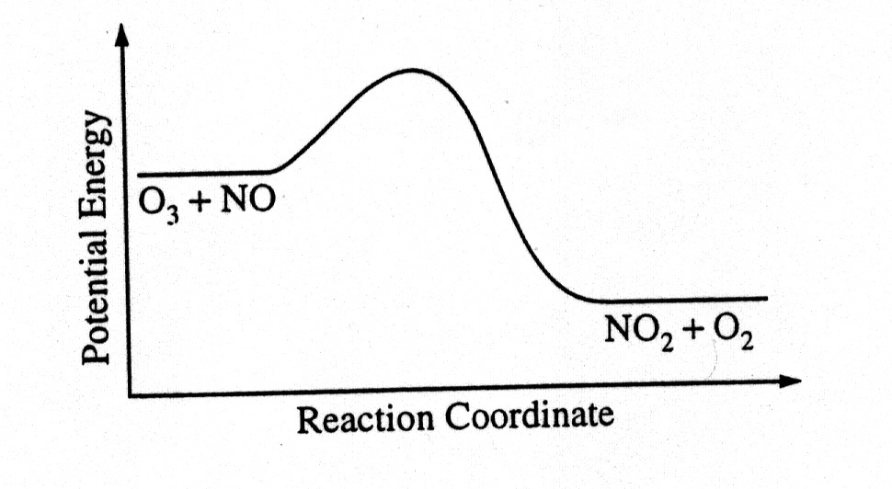

b. The reaction 2 N2O5 → 4 NO2 + O2 is first order with respect to N2O5.

i. Using the axes at right, complete the graph that represents the change in [N2O5] over time as the reaction proceeds.

ii. Describe how the graph in part i could be used to find the reaction rate at a given time, *t*.

iii Considering the rate law and the graph in part i, describe how the value of the rate constant, *k*, could be determined.

iv. If more N2O5 were added to the reaction mixture at constant temperature, what would be the effect on the rate constant, *k*? Explain.

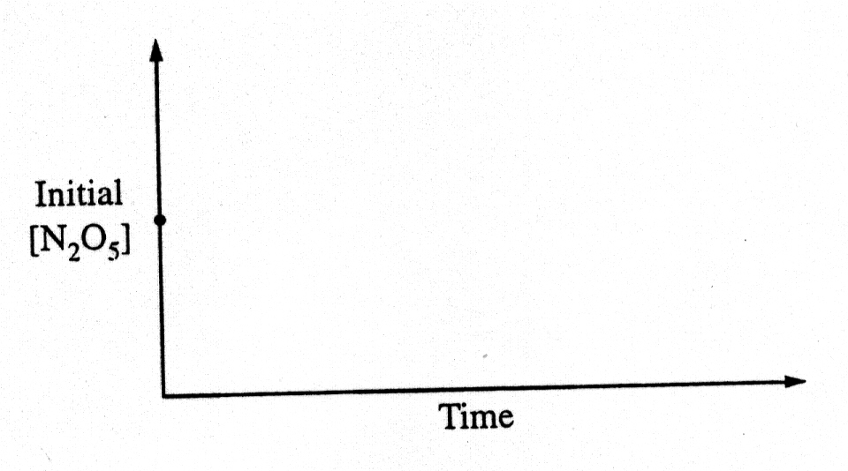

c. Data for the chemical reaction 2A → B + C were collected by measuring the concentration of A at 10-minute intervals for 80 minutes. The following graphs were generated from analysis of data.

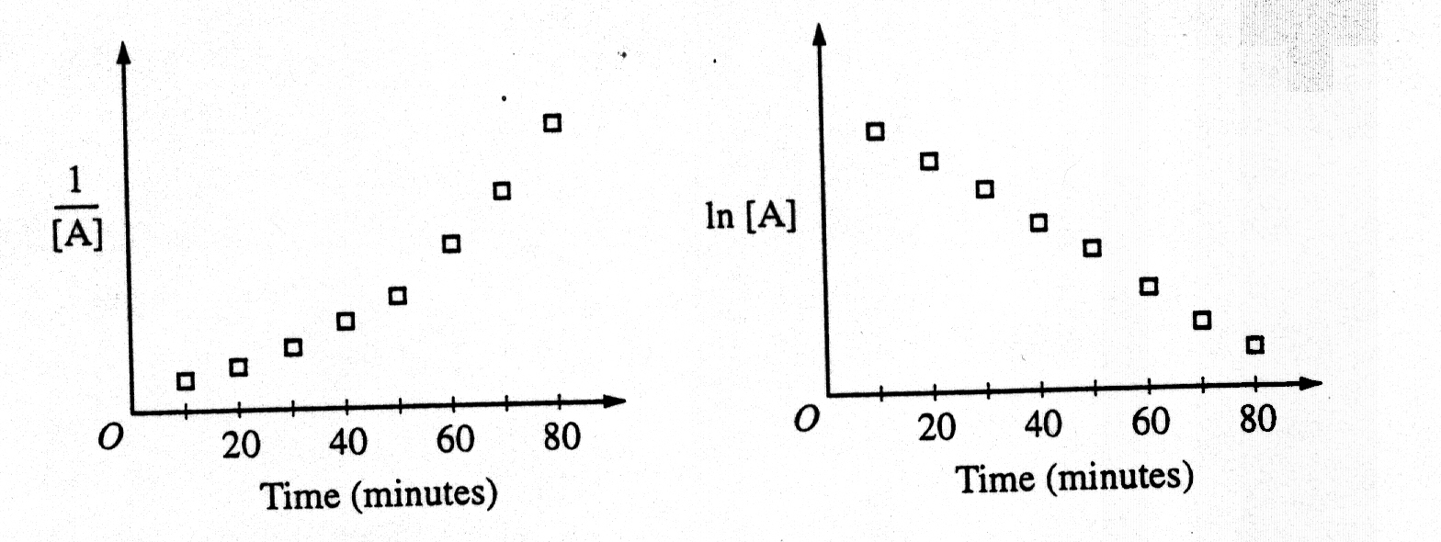

Use the information in the graphs above to answer the following.

i. Write the rate-law expression for the reaction. Justify your answer.

ii. Describe how to determine the value of the rate constant for the reaction.

*8 point*

*a) Response must clearly indicate (and distinguish between) Eact and ΔHrxn on graph.*

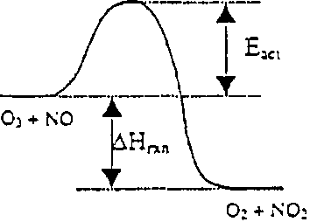

*Each earns one point (2 total)*

*bi). Response shows a softly curving line that approaches the time axis*

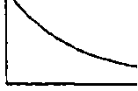

*and whose slope changes continually*

*No penalty if curve crosses time axis or levels out above time axis.*

*Curve must drop initially and continually. No credit earned if [N2O5] increases.*

*ii. Reaction Rate is the slope of the line tangent to any point on the curve.*

*Rate must be tied somehow to slope of graph.*

*Answer may be indicated directly on the graph.*

*Instantaneous rate must be indicated rather than the average rate*

*iii) Since rate = slope = k[N205], the value of k can be determined algebraically from the slope at a known value of [N205].*

*No penalty for Rate =2k[N2O5], as reaction stoichiometry could suggest this answer.*

*Point can be earned for rate constant = slope of graph of ln[N2O5] vs. time since reaction is first order.*

*Use of half-life or integrated rate law to solve for k can be accepted.*

*iv. The value of the rate constant is independent of the reactant concentrations, so adding more reactant will not affect the value of k.*

*No point earned for simply stating that value of k will not change.*

*Response must distinguish between rate. and rate constant.*

*bi. Rate = k[A] or ln ([A]/[A]0) = -kt. Since graph of ln [A] vs. time is linear, it must be a first-order reaction.*

*Either form of the rate law is acceptable, and both the equation and the brief justification are required to earn the point*

*No point earned if response indicates first order because the first graph is not linear.*

*ii. Determine the slope of the second graph and set “k= - slope”*

*Response must indicate both the negative sign and the slope.*

**Multiple Choice Questions**

**1999 #36**

|  |  |  |  |
| --- | --- | --- | --- |
| Experiment | Initial [NO] (mol L-1 ) | Initial [O2] (mol L-1) | Initial Rate of Formation of NO2 (mol L-1 s-1) |
| 1 | 0.10 | 0.10 | 2.5 × 10-4 |
| 2 | 0.20 | 0.10 | 5.0 × 10-4 |
| 3 | 0.20 | 0.40 | 8.0 × 10-3 |

The initial-rate data in the table above were obtained for the reaction represented below. What is the experimental rate law for the reaction?

A) rate = k[NO] [O2]  
**B) rate = k[NO] [O2]2** (52%)  
C) rate = k[NO]2 [O2]  
D) rate = k[NO]2 [O2]2  
E) rate = k[NO] / [O2]

**2008 #32** Gaseous cyclobutene undergoes a first-order reaction to form gaseous butadiene. At a particular temperature, the partial pressure of cyclobutene in the reaction vessel drops to one-eighth its original value in 124 seconds. What is the half-life for this reaction at this temperature?

A) 15.5 sec

B) 31.0 sec

**C) 41.3 sec** (38%)

D) 62.0 sec

E) 124 sec

**1999 #63**

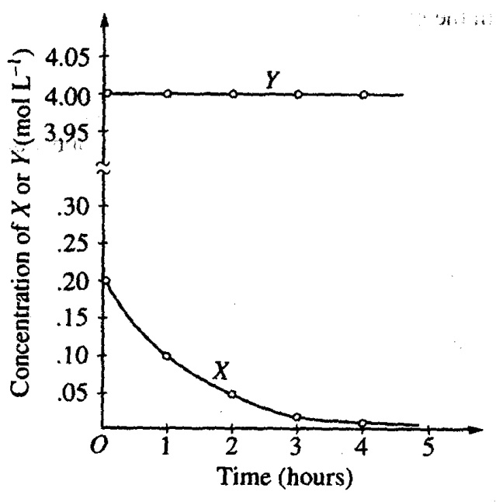

The graph above shows the results of a study of the reaction of X with a large excess of Y to yield Z. The concentrations of X and Y were measured over a period of time. According to the results, which of the following can be concluded about the rate of law for the reaction under the conditions studied?

A) It is zero order in [X].  
**B) It is first order in [X].** (34%)  
C) It is second order in [X].  
D) It is the first order in [Y].  
E) The overall order of the reaction is 2.

**2002 #27** 2 NO(g) + O2(g) 🡪 2 NO2(g)

A possible mechanism for the overall reaction represented above is the following

(1) NO(g) + NO(g) 🡪 N2O2(g) slow

(2) N2O2(g) + O2(g) 🡪 2 NO2(g) fast

Which of the following rate expressions agrees best with this possible mechanism?

**A) Rate = k [NO]2** (45%)

B) Rate = k [NO] / [O2]

C) Rate = k [NO]2 / [O2]

D) Rate = k [NO]2 [O2]

E) Rate = k [N2O2] [O2]

**2002 #54** Which of the following must be true for a reaction for which the activation energy is the same for both the forward and reverse reactions?

A) A catalyst is present.

B) The reaction order can be obtained directly from the balanced equation.

C) The reaction order is zero.

**D) Δ*H* for the reaction is zero.** (43%)

E) Δ*S* for the reaction is zero.